

[Artificia](https://doi.org/10.1016/j.ailsci.2022.100055)l[IntelligenceintheLifeSciences3(2023)100055](https://doi.org/10.1016/j.ailsci.2022.100055)

|  |  |  |
| --- | --- | --- |
|  | Contentslistsavailableat[ScienceDirect](http://www.ScienceDirect.com) |  |
| ArtificialIntelligenceintheLifeSciences |
| journalhomepage:[www.elsevier.com/locate/ailsci](http://www.elsevier.com/locate/ailsci) |

Review

Artificialintelligencesystemsforthedesignofmagicshotgundrugs

José TeófiloMoreira-Filhoa,1,MeryckFelipeBritodaSilvaa,1,JoyceVillaVerdeBastosBorbaa, ArlindoRodriguesGalvãoFilhob,EugeneNMuratovc,d,CarolinaHortaAndradea,   
RodolphodeCamposBragae,BrunoJuniorNevesa,∗

a*LabMol– LaboratoryforMolecularModelingandDrugDesign,FaculdadedeFarmácia,UniversidadeFederaldeGoiás,Goiânia,GO,Brazil*   
b*InstituteofInformatics,FederalUniversityofGoiás,Goiânia,GO,Brazil*   
c*LaboratoryforMolecularModeling,UNCEshelmanSchoolofPharmacy,UniversityofNorthCarolinaChapelHill,NorthCarolina,UnitedStatesofAmerica* d*DepartmentofPharmaceuticalSciences,FederalUniversityofParaíba,JoaoPessoa,PB,Brazil*   
e*InsilicAllLtda,SãoPaulo,SP,Brazil*

|  |  |  |
| --- | --- | --- |
| article | info | abstract |
| *Keywords:*  Multi-targetdrugs Deeplearning  Predictivemodeling Denovodesign  Multi-tasklearning |  | Designingmagicshotguncompounds,i.e.,compoundshittingmultipletargetsusingartificialintelligence(AI) systemsbasedonmachinelearning(ML)anddeeplearning(DL)approaches,hasahugepotentialtorevolutionize drugdiscovery.Suchintelligentsystemsenablecomputerstocreatenewchemicalstructuresandpredicttheir multi-targetpropertiesatalowcostandinatime-efficientmanner.MostexamplesofAIappliedtodrugdiscovery aresingle-targetorientedandthereisstillalackofconciseinformationregardingtheapplicationofthistech-nologyforthediscoveryofmulti-targetdrugsordrugswithbroad-spectrumaction.Inthisreview,wefocuson currentdevelopmentsinAIsystemsforthenextgenerationofautomateddesignofmulti-targetdrugs.Wediscuss howclassicalMLmethods,cutting-edgegenerativemodels,andmulti-taskdeepneuralnetworkscanhelp*denovo* designandhit-to-leadoptimizationofmulti-targetdrugs.Moreover,wepresentstate-of-the-artworkflowsand highlightsomestudiesdemonstratingencouragingexperimentalresults,whichpavethewayfor*denovo*drug designandmulti-targetdrugdiscovery. |

**1.Introduction**

Theprinciple“onetarget,onedrug” hasbeentheimperativestrategy indrugdiscoveryflowchartsformanydecades.Thisparadigmisbased onthepremisethatselectivedrugstargetingasinglebiologicaltarget (e.g.,enzymeorreceptor)mayavoidsideeffectsarisingfrombinding

tootherbiologicaltargets(“off-targets” effects)[1].Althoughnumerous single-targetdrugshavebeenclinicallyeffective,experiencehasshown thatexcessiveselectivitymaysometimeshavefatalconsequences[2,3]. Inaddition,thesemoleculeshavelimitedefficacyagainstcomplexdis-eases(e.g.,diabetes,cancer,neurodegenerativediseases,metabolicsyn-drome,andatherosclerosis)[4,5]inwhichthepathogenesisisdepen-

*Abbreviations:*5-HT1A,serotoninsubtype1Areceptor;5-HT2A,serotoninsubtype2Areceptor;AI,artificialintelligence;A1AR,A1AdenosineReceptor;A2AAR, A2AAdenosineReceptor;ANN,artificialneuralnetworks;BRAF,serine/threoninekinaseproteinB-raf;CADD,computer-assisteddrugdesign;Cmax,maximum serumconcentration;CNN,convolutionalneuralnetworks;D1,DopaminereceptorD1;D2,DopaminereceptorD2;DT,decisiontrees;ELU,ExponentialLinearUnit; ECFPs,extended-connectivityfingerprints;ECFP4,extended-connectivityfingerprintswithdiameter4;FCFPs,functional-classfingerprints;FDA,U.S.FoodandDrug Administration;FNN,feed-forwardneuralnetworks;GPU,graphicalprocessingunits;GRU,gatedrecurrentunit;hERG,Ether-à-go-go-RelatedGene;HTS,high throughputscreening;IC50,halfmaximalinhibitoryconcentration;LSTM,long-short-termmemory;MACCS,MolecularACCessSystem;ML,machinelearning;MOO, multi-objectiveoptimization;MTL-DNN,multi-tasklearningdeepneuralnetwork;PD,promiscuitydifference;PCM,proteochemometricmodeling;PDGFR,platelet-derivedgrowthfactorreceptor;pEC50,minusofhalfmaximaleffectiveconcentration;PK,pharmacokinetics;pKi,minusofbindingaffinity;MOSES,Molecular Sets;NSGA-II,non-dominatedsortinggeneticalgorithm;QSAR,quantitativestructure-activityrelationships;ReLU,RectifiedLinearUnit;RF,randomforest;RNN, recurrentneuralnetworks;SELFIES,SELF-referencIngEmbeddedStrings;SMILES,simplifiedmolecularinputlineentryspecification;SVM,supportvectormachines; T1/2,Half-lifetime;Tmax,Timetopeakdrugconcentration;TPU,tensorprocessingunits;VEGFR,vascularendothelialgrowthfactorreceptor.

∗Corresponding[author:Dr.BrunoJ](mailto:brunoneves@ufg.br)uniorNeves,FederalUniversityofGoias,Brazil.

*E-mailaddress:*[brunoneves@ufg.br](mailto:brunoneves@ufg.br)(B.J.Neves).

1Theseauthors[contributedequally](mailto:brunoneves@ufg.br)tothisstudyandshouldbeconsideredasco-firstauthors.

<https://doi.org/10.1016/j.ailsci.2022.100055>  
[Received19September2022;Receivedinrev](https://doi.org/10.1016/j.ailsci.2022.100055)isedform13December2022;Accepted21December2022   
Availableonline22December2022   
2667-3185/© 2023PublishedbyElsevierB.V.ThisisanopenaccessarticleundertheCCBY-NC-NDlicense(<http://creativecommons.org/licenses/by-nc-nd/4.0/>)

*J.T.Moreira-Filho,M.F.B.daSilva,J.V.V.B.Borbaetal.*  *ArtificialIntelligenceintheLifeSciences3(2023)100055*

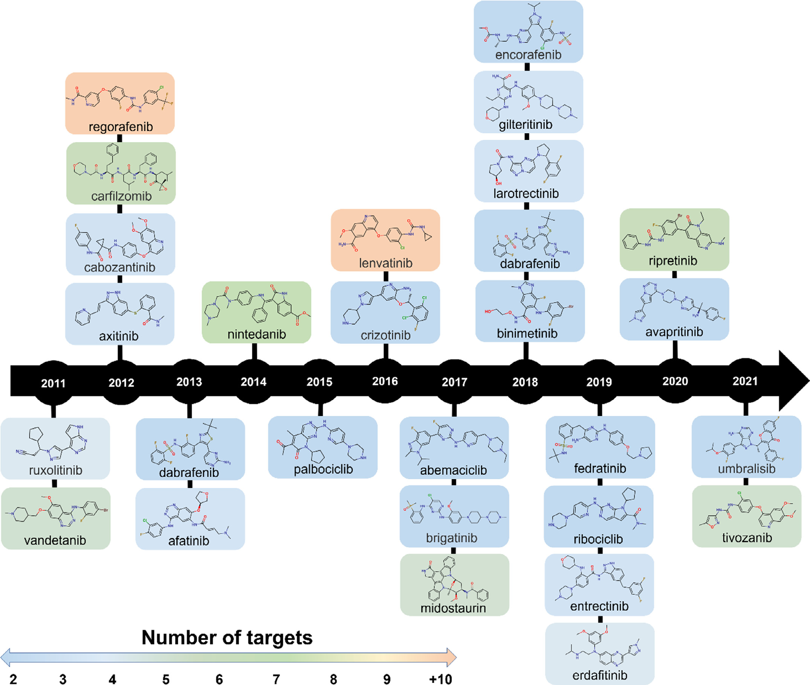

**Fig.1.**Examplesofmulti-targetdrugsapprovedbyFDAinthelastdecade.

dentonasetofbiologicaltargetsoperatingconcomitantly[6].Con-sequently,apoorcorrelationbetweeninvitroselectivityandinvivo efficacyisoftenfoundforcomplexdiseases[7,8].

Undersuchaperspective,multi-targetormagicshotgundrugs emergedasefficienttherapeuticsolutionstoovercomedrug-resistance issuesandincreaseefficacyagainstcomplexdiseases[9].Multi-target drugscontrasttheclassicaldrugdesignparadigmbymodulatingmul-tiplerelevanttargetsforthedisease[10].Consequently,multi-target drugdesignhastriggeredtheinterestofmedicinalchemists,abandon-ingitsstatusasanemergingparadigm[11,12]tobecomeoneofthe mosteffectiveapproachesfordrugdiscovery[7–9].

Themostsuccessfulmulti-targetdrugstodatehavebeenkinasein-hibitors,duetotheimportantrolekinasesplayincriticalbiological pathwayssuchascancerdevelopmentandprogression.Overthepast decade,severalmulti-kinaseinhibitorsemergedfromthedrugdiscov-erypipelinesintoclinicaluse[13].AsshowninFig.1,twenty-eightan-ticancerdrugstargetingthehumankinomewereapprovedbytheU.S. FoodandDrugAdministration(FDA)between2011and2021.Theseap-proveddrugscopewiththemultifactorialnatureofcancerbysimultane-ouslytargetingmultipletyrosinekinases.Forexample,thetherapeutic

2

*J.T.Moreira-Filho,M.F.B.daSilva,J.V.V.B.Borbaetal.*

drugdiscoveryfieldintothe“bigdata” era[21].Consequently,mas-siveamountsofdatacanbefoundinpublicdomaindatabasesofdif-ferentcategories,including:bioactivitydatabases(PubChem[22]and ChEMBL[23]);databasesforthree-dimensionalstructures(RCSBPro-teinDataBank(PDB)[24]);protein-proteininteractiondatabases (STITCH[25]andSTRING[25]);pathway/genomedatabases(BRENDA [26]andBioCyc[27]);chemicaltoxicologydatabases(CompTox [28]andEFSA’sOpenFoodToxdatabase[29]);andclinicaldatabases (ClinicalTrials.gov[30]andPharmaGKB[31]).Thefullexploitationof theserichsourcesofdataisofhighinteresttoresearchersinthefield ofcheminformaticsandcomputer-assisteddrugdesign(CADD).

Many*insilico*methodshavebeendevelopedtoapproachdata-driven multitargetdrugdesign.Thesemethodsareusuallycategorizedaseither ligand-based(e.g.,pharmacophoremodeling)orstructure-based(e.g., moleculardocking),dependingonwhetherligandandstructuralinfor-mationareavailable[32].However,thepotentialforexploringthese toolsremainsuntappedsincemost*insilico*examplesofdrugdiscovery aresingle-targetoriented.Thus,thereisaneedforinnovativetechnolo-giestohandlecomplexdataandtransformthemintousefulinformation, offeringameanstowardsdata-drivendecisionsandtheconsequentde-velopmentofmulti-targetdrugswithbroad-spectrumaction[33–35].

Inrecentyears,artificialintelligence(AI)approachesbasedon machinelearning(ML)haveemergedaspromisingalternativesthat improvedecision-makinginthecontextofmulti-targetdrugdesign [17,36,37].MLisasubfieldofAIthatusesdifferentalgorithmstoenable computerstomakeefficientpredictionsfrompastobservationswithout beingcontinuallyprogrammedtothistask[38–41].Thesemethodsare abletohandlemulti-objectiveoptimization(MOO)problems,suchas thediscoveryofmulti-targetcompounds,navigatinghugedatasets,and allowingbetterdecisions[34].Inthisreview,wefocusonrecentde-velopmentsinAItechnologiesfortheautomateddesignofmulti-target drugs.Wealsohighlightliteratureexamplesimplementinginnovative workflowsandsuggestpossiblesolutionstoexistingpitfalls.

**2.Machinelearningmethods**

Morethan50yearsago,classicalquantitativestructure-activityrela-tionship(QSAR)modelingstartedusinglinearmodelssuchaslinearre-gressionand*k*-nearestneighborstomakepredictionsofchemicalprop-erties[42–44].Beginningintheearly2000s,QSARapproachespro-gressedtomoresophisticatedandnon-linearMLmethods,especially Decisiontrees(DTs),randomforest(RF),andsupportvectormachines (SVMs)[45,46].DTsconsistsofagroupofrulesthatenableestablish betweenmolecularfeatures(representedasmoleculardescriptors)and theactivityofthecompounds[47,48].

DTsaretree-shaped,presentingarootnodeatthetop,wherethe dataisdividedintobranches.Thesebrancheswillcontinuetodivide intograduallysmallersubsetsuntilanoutcome(representedasaleaf node)isreached[17,49].DTsaresimpletointerpretandvalidateand flexibleenoughtodealwithnumericalandcategoricalinputsandmul-ticlassproblems[17,50,51].ThedisadvantagesofDTsincludetheloss ofperformanceinnoisyorincompletedata,andthesensitivitytohigh variancedata(i.e.,smallchangescanresultindifferentdatasplitsand propagationoferrors)[49,52].Anapproachtoalleviatingthebiasand varianceproblemistheuseofanensembleofDTs[53].Inthissense, oneofthemostwidelyusedandbest-performingensemblealgorithms isRF(Fig.2a)[54,55].RFcomprisesanensembleofindividualDTs constructedusingdifferentsubsetsobtainedfromthetrainingdatawith replacement[56].Thereafter,predictionsforunseendataareobtained viamajorityvoting(classification)orpredictions(regression)ofthein-dividualtrees.

Anothernon-linearMLmethodistheSVMalgorithmdeveloped byVapnikandcoworkers[57,58].SVMisasupervisedMLalgorithm abletoperformregressionandclassificationtasksforcompoundprop-erty/activitypredictions[48].AsshowninFig.2b,SVMtransformsthe originalmoleculardescriptorsspaceintoahigh-dimensionalfeature

3

*J.T.Moreira-Filho,M.F.B.daSilva,J.V.V.B.Borbaetal.*

ofdifferentmodelsusingpositiveandnegativefactors.Consequently, refinedmodelsefficientlydistinguishedbetweencompoundswithover-lappingactivityprofiles.

Inrecentdecades,proteochemometricmodeling(PCM)hasemerged asasuitabletechniquefordiscoveringmulti-targetdrugs[64,65].PCM isacomputationalchemogenomicapproachthatdrawsheavilyonre-centMLdevelopments.ThePCMmodelscanbetrainedondatasets composedofaseriesofcompoundsandproteintargetsorbindingpock-ets(i.e.,toallowdistinctionbetweenallosteric/orthostericbindingand bindingmodes),whereideally,compoundshavebeenmeasuredonas manytargetsaspossible[64].Thesimultaneousmodelingoftheligand descriptor(e.g.,Hashedfingerprints,circularfingerprints,MACCSkeys, atomcounts)andtargetdescriptor(e.g.,Atom-typebased,Z-scales,se-quencedescriptors)spacesandcross-termdescriptors(i.e.,anadditional classofdescriptorsthatmultipliesligandandtargetdescriptors)allows theresearchertounderstandbettercomplexdrug–targetinteractions (e.g.,multi-targetprofile)astheinfluenceoftargetvariabilityoncom-poundactivitycanbeevaluated[64].

**3.Theriseofdeeplearning**

Theterm“DeepLearning(DL)” referstoagrowingfieldofMLthat usesArtificialNeuralNetworks(ANNs)composedofmultiplehidden layers,alsocalledDeepNeuralNetworks(DNNs),forlearningdatarep-resentations.ThestructureoftheseDNNsmimicstheoperationsofneu-ronsfoundinthecerebralcortextolearnfromfeaturerepresentations ofdatawithmultiplelevelsofabstraction[66–68].Muchoftheexten-sivepopularizationofDLisrelatedtocloudcomputing[69]andthe availabilityofnewhardwaretechnologies,suchasgraphicalprocessing units(GPUs)[70]andtensorprocessingunits(TPUs)[71],thatallowed researcherstotrainnetworksupto35timesfaster.Importantly,the mainadvantageofDListheabilitytolearncomplexfeaturesfrommas-sivevolumesofdata.Fig.3ashowsthecomparisonbetweenDLandML performanceasthetrainingdatasizeincreases.Forsmallerdatasets,ML algorithmsusuallyshowbetterperformanceascomparedtoDL[72,73]. Ontheotherhand,whentheamountofdataincreases,theperformance ofMLmethodsreachesasaturationpointanddoesnotimproveanyfur-ther,whereastheperformanceofDLkeepsincreasing[72].Forinstance, recently,Mayretal.[74]showedthatDNN-basedarchitecturestrained usingalarge-scaledrugdiscoverydatasetsignificantlyoutperformedall competingclassicalMLmethods(KNN,SVM,RandomForest,andNaive Bayes).However,thesuperiorperformanceofDLoverMLmodelshas notbeenconsistentlyobservedinapplicationsusingdatasetsofdiffer-entoriginsandcompositions[75,76].Katoetal.[76]suggestthatthe performanceofDLandMLmodelsmaybeimpactedbytheinsufficient levelofmolecularfeaturerepresentationstopredictcomplexbiological mechanismsobservedinmolecularactivitymeasurements[76].Inad-dition,alternativedatasplittingstrategiesandtheresultingtestsystems (hyperparameters)caninfluencetherelativeperformanceofmodels,es-peciallyforthemostchallengingcompounddatasets[75,77].

Thefullyconnectedfeedforwardneuralnetwork(FNN)wasthefirst andsimplesttypeofDNNdevised.AtypicalFNNcontainsmanyartifi-cialneuronsarrangedinthreetypesoflayers(Fig.3b)[78]:

•Inputlayer:acceptstheinputdataandpassesittothefirsthidden layer;  
•Hiddenlayers:locatedbetweentheinputandoutputofthealgo- rithm.Thehiddenlayersperformnon-lineartransformationsonthe inputdatathatwillproduceapredictedoutputthatiscloseenough totheexpectedoutput;  
•Outputlayer:ismostlyresponsibleforproductionoutputpredic- tions.

Thenetworkiscomposedofaninterconnectedsystemofperceptrons thatactasbasicinformation-processingunits.Fig.3cdisplaysapercep-troninmoredetail.Theperceptronalgorithmconsistsoffourparts:(i) inputvalues,(ii)weightsandabias,(iii)aweightedsum,and(iv)an

4

*J.T.Moreira-Filho,M.F.B.daSilva,J.V.V.B.Borbaetal.*  *ArtificialIntelligenceintheLifeSciences3(2023)100055*

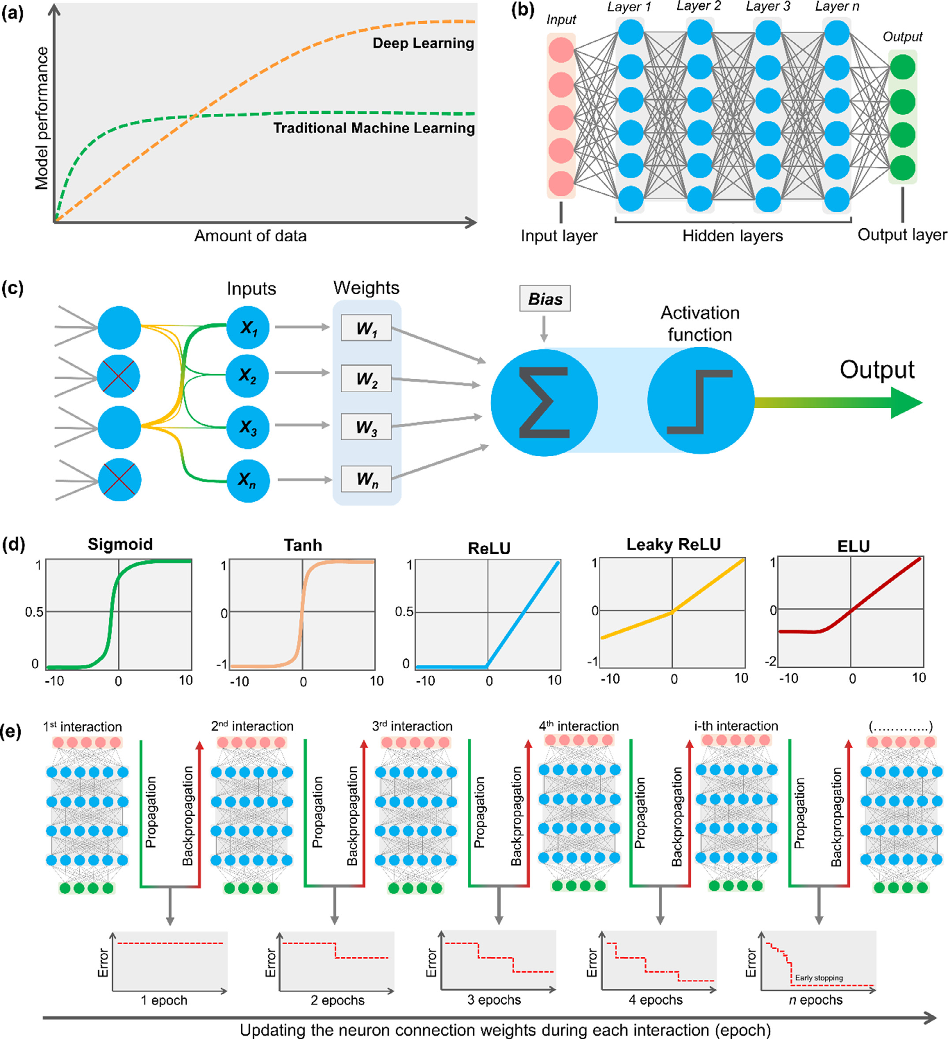

**Fig.3.**LearningprocessbasedonDNNs.**(a)**PerformanceofMLvs*.*DLmodelswithrespecttotheamountofdata;**(b)**ArchitectureofatypicalFeedforwardNeural

Network(FNN);**(c)**Perceptronmodel;**(d)**Frequentlyusedactivationfunction;**(e)**ForwardpropagationandbackpropagationoferrorintypicalDNNs.

Eacharchitecturehasadvantagesanddisadvantages,whicharerelated tothetypeoffeaturebeingmodeled.

ThefullyconnectedFNN(Fig.3b)isthemostcommonarchitecture ofDNNs.Inthisnetwork,theinformationmovesinasingledirection, fromtheinputlayertotheoutputlayer,withoutloopsorbackwardcon-nections[85].Already,theRNNsweredesignedtoidentifypatternsin sequentialdata,suchasSimplifiedMolecularInputLineEntrySpeci-

5

*J.T.Moreira-Filho,M.F.B.daSilva,J.V.V.B.Borbaetal.*  *ArtificialIntelligenceintheLifeSciences3(2023)100055*

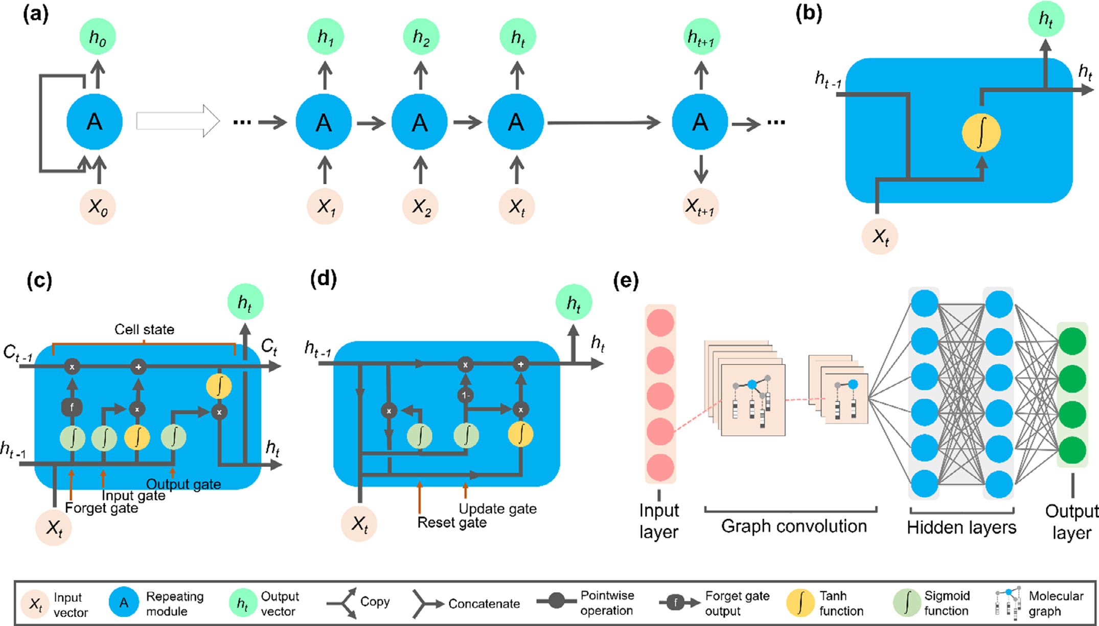

**Fig.4.**Deeplearningzoo.**(a)**TheunfoldedRecurrentNeuralNetwork(RNN).Structurediagramofthe**(b)**defaultRNN,**(c)**Long-Short-TermMemory(LSTM),**(d)**

GatedRecurrentUnit(GRU),and**(e)**GraphConvolutionalNeuralNetwork(GCNN)architectures.

layerA(recurrentstate),andtheoutputlayer*h0*.Ifthehiddenlayer loopisunfolded,thedefaultRNNscopythesamestructuremultiple times,andthe“statevector” A(memory)ofeachcopyistakenasinput toitssuccessor[85].Thus,RNNsareamemory-gatedarchitecture:they allowtheevaluationofnewinputsthroughpersistentinformationfrom previousstates,meaningthatthesameinputcouldproduceadifferent outputdependingonpreviousinputsintheseries[102].However,a defaultRNN(Fig.4b)isunabletocapturetemporaldependenciesthat extendtomorethanalimitednumberoftimesteps(long-termdepen-dencies).Therefore,Long-Short-TermMemory(LSTM)[89]andGated RecurrentUnit(GRU)[90]networksspecificallyaddressthislimitation. ComparedtothedefaultRNN(Fig.4b),thecellstateofLSTM (Fig.4c)architecture,introducedbyHochreiterandSchmidhuber[89], offersasolutionforvanishing/explodinggradientsbypreservingand learninglong-termdependenciesindata.AsshowninFig.4c,LSTM usesthreegatestocontrolacellstate(*𝐶𝑡*):(i)forgetgate,(ii)inputgate, and(iii)outputgate.Theforgetgatedecideswhichinformationneeds attentionandwhichcanbeignored.Theinformationfromthecurrent input(*𝑋𝑡*)andprevioushiddenstate(*ℎ𝑡*−1)ispassedthroughaSigmoid function.Thisfunctiongeneratesvaluesbetween0and1,whichare multipliedbythepreviouscellstate(*𝐶𝑡*−1)[90,91].Theinputgatethen decideswhatnewinformationcanbestoredinthecellstate.Thisis usuallycontrolledbyaSigmoidfunctionthatdecideswhichvalueswill beupdatedandaTanHoperatorthatcreatesavectorofnewcandidate values(between−1and1).Theoutputvaluesgeneratedfromtheseac-tivationfunctionsarepoint-by-pointmultipliedandthenaddedtothe cellstate.Finally,anoutputgatedeterminesthevalueofthenexthid-denstate(*ℎ𝑡*).Inthisstep,thevaluesofcurrentandprevioushidden statesarepassedintoSigmoidandTanHfunctions.Boththeseoutputs aremultipliedpoint-by-point.Ultimately,baseduponthefinalvalues, thenetworkdecideswhichinformationthe*ℎ𝑡*shouldcarry[90,91]. TheGRU[90](Fig.4d)wasproposedasvariantofLSTMtosupport gatingandahiddenstatetocontroltheflowofinformation.Whencom-

6

*J.T.Moreira-Filho,M.F.B.daSilva,J.V.V.B.Borbaetal.*

neuralfingerprintencodingchemicalinformation.Finally,theneural fingerprintsarepassedthroughanotherfullyconnectedneuralnetwork togeneratethefinaloutputtask[68].

AmongGCNNrepresentations,geometricDLapproacheshavebeen employedforpredictingthebindingconformationsofligandstopro-teintargets.Concretely,themodellearnsbasedondistancelikelihood whichistailor-madeforeachligand-targetpair.Inthefirststep,the neuralnetworkextractsapoolofmesh(i.e.,collectionofnodes,edges, andfaces)whichdefinestheshapesofthemolecularsurfacesofbind-ingsites.Inasimilarway,ligandsarerepresentedasatwo-dimensional undirectedgraph,whereatomsandbondsarerepresentedbynodesand edges,respectively.Boththetargetmeshandtheligandgrapharepro-cessedbyindependentresidualGCNNs.Inthefollowingstep,thepro-cessedfeaturesfromtheproteintargetsandligandsareconcatenated usingamixturedensitynetworktomodeltheinteractionoftheligands withthetargets[99].

*ArtificialIntelligenceintheLifeSciences3(2023)100055*

dictionmodelsandadvancingtheunderstandingofthesedrugtargets. Toovercomethisissue,aMTL[110,111]wasdevelopedtopredictthe kinome-wideactivityprofilesofuntestedcompounds.Initially,thenet-workwastrainedwithover170,000bioactivitydatapoints(∼32,000 chemicalstructuresandof391kinases)usingECFP4fingerprintsasin-puts[110,111].Then,thetra[inedMTDNNwasimplemen](https://kinome.dddc.ac.cn)tedtothepub-licintheKinomeXwebapp(<https://kinome.dddc.ac.cn>)[110].

Thisapphasanintuitive[userinterface,inwhichthe](https://kinome.dddc.ac.cn)usermaydraw acompoundofinterestordirectlysubmittheSMILESstringofaqueried chemicalstructuretoprediction.Giventheverifiedgeneralizabilityof KinomeX,Liandcoworkers[111]thenperformedacomprehensive*in silico*analysisofdiversecompoundswithunknownkinaseactivitypro-files(Fig.5a).Importantly,theexperimentalvalidationofthepredicted spectrumshowssignificantagreementwiththeexperimentaldata,sug-gestingthatKinomeXcanbeusedtodiscovermulti-targetkinasein-hibitors[111].

*3.1.Multi-tasklearning*  *3.2.Denovodesign*

Totacklethechallengesofmulti-targetdrugdesign,numerousef-fortsarebeingmadeintheDLfieldtodevelopmulti-taskmodels.Multi-tasklearning(MTL)isaninductivetransferapproachinwhichmultiple tasks(e.g.,targets)aresimultaneouslylearnedbyasharedmodel.Such anapproachisparticularlyinterestingsinceMTL-DNNscanexplorerep-resentationslearnedacrossdifferenttasksandboosttheperformanceof taskswithfewertrainingexamples[100,101].Previousstudiessuggest thatMTLcanofferastrongimprovementinpredictiveperformanceover single-taskmethods[102].AccordingtoRodríguezPérezandBajorath [75],MTLmodelsprovidedincrementaladvantagesforpredictingthe mostchallengingbiologicalproperties.WhenMTLmodelswereevalu-atedontasksthatsharechemicalinformation,theobtainedresultswere generallysuperiortosingle-tasklearning(STL)models.Incaseswhere STLmodelaccuracywaslimited,thelargestrelativeperformancegains ofMTLmodelswereobserved[75].

ThereareseveralapproachesforoptimizingandcalibratingMTL models.Existingworksoftenfocusondevelopingaggregatedlossfunc-tionsadaptedtosparsedataasawaytolearnmultipletasksatonce. DifferentlossweighingmechanismsmaybeusedtoaidMTLoptimiza-tion,suchasaddingweightstotheindividuallossfunctionstoprevent ataskwithmoredatafromdominatingtheoptimization[103].

MostexistingMTLmodelsarebasedonsharingparametersacross hiddenlayers.Theparameter-sharingmechanismsinMTLaredivided intofourcategories:(i)hardparametersharing[104],(ii)softparam-etersharing[104],(iii)hierarchicalsharing[105,106],and(iv)sparse sharing[107,108].Inhardparametersharing,thehiddenlayersofthe neuralnetworkaresharedwhilekeepingsometask-specificoutputlay-ers.Sharingmostofthelayersfortherelatedtasksreducesthechances ofoverfitting,butwhentasksconflict,thelearningiseasilyaffected bynegativetransferring,whichisharmfultothemodelperformance [104].Thesoftparametersharingmechanismhasindependentparam-etersandsubnetforeachtask,buttheirinformationcanbemutually learned.Theapproachregularizesthedistancebetweentheparameters oftheindividualsubnetstotheoveralltrainingobjectivetoencourage similarmodelparametersbetweenthedifferenttasks[104].Thehier-archicalsharingconsiderstheprogressiverelationshipbetweentasks, whichmeansthatataskmaybeasubtaskofanotherone,thusplacing themondifferentnetworklayers[104–106].Ontheotherhand,thehi-erarchicalsharingmechanismmaybeacomplexproblemthatrelieson priorknowledgeoftaskrelations[104,109].Thesparsesharingmech-anismautomaticallyextractssubnetsforeachtaskbasedontheideaof thelotterytickethypothesis.Theobtainedsubnetsareoverlappedand trainedinparallel[107,108].

TheMTLmodelingispotentiallyusefulfordesigningmulti-kinase inhibitors,giventhataconsiderablenumberofkinasesremainspoorly studiedandthelabeledcompoundsforsuchtargetsarescarce.Conven-tionally,thislimitstheopportunitiesforconstructinghigh-qualitypre-

7

*J.T.Moreira-Filho,M.F.B.daSilva,J.V.V.B.Borbaetal.*  *ArtificialIntelligenceintheLifeSciences3(2023)100055*

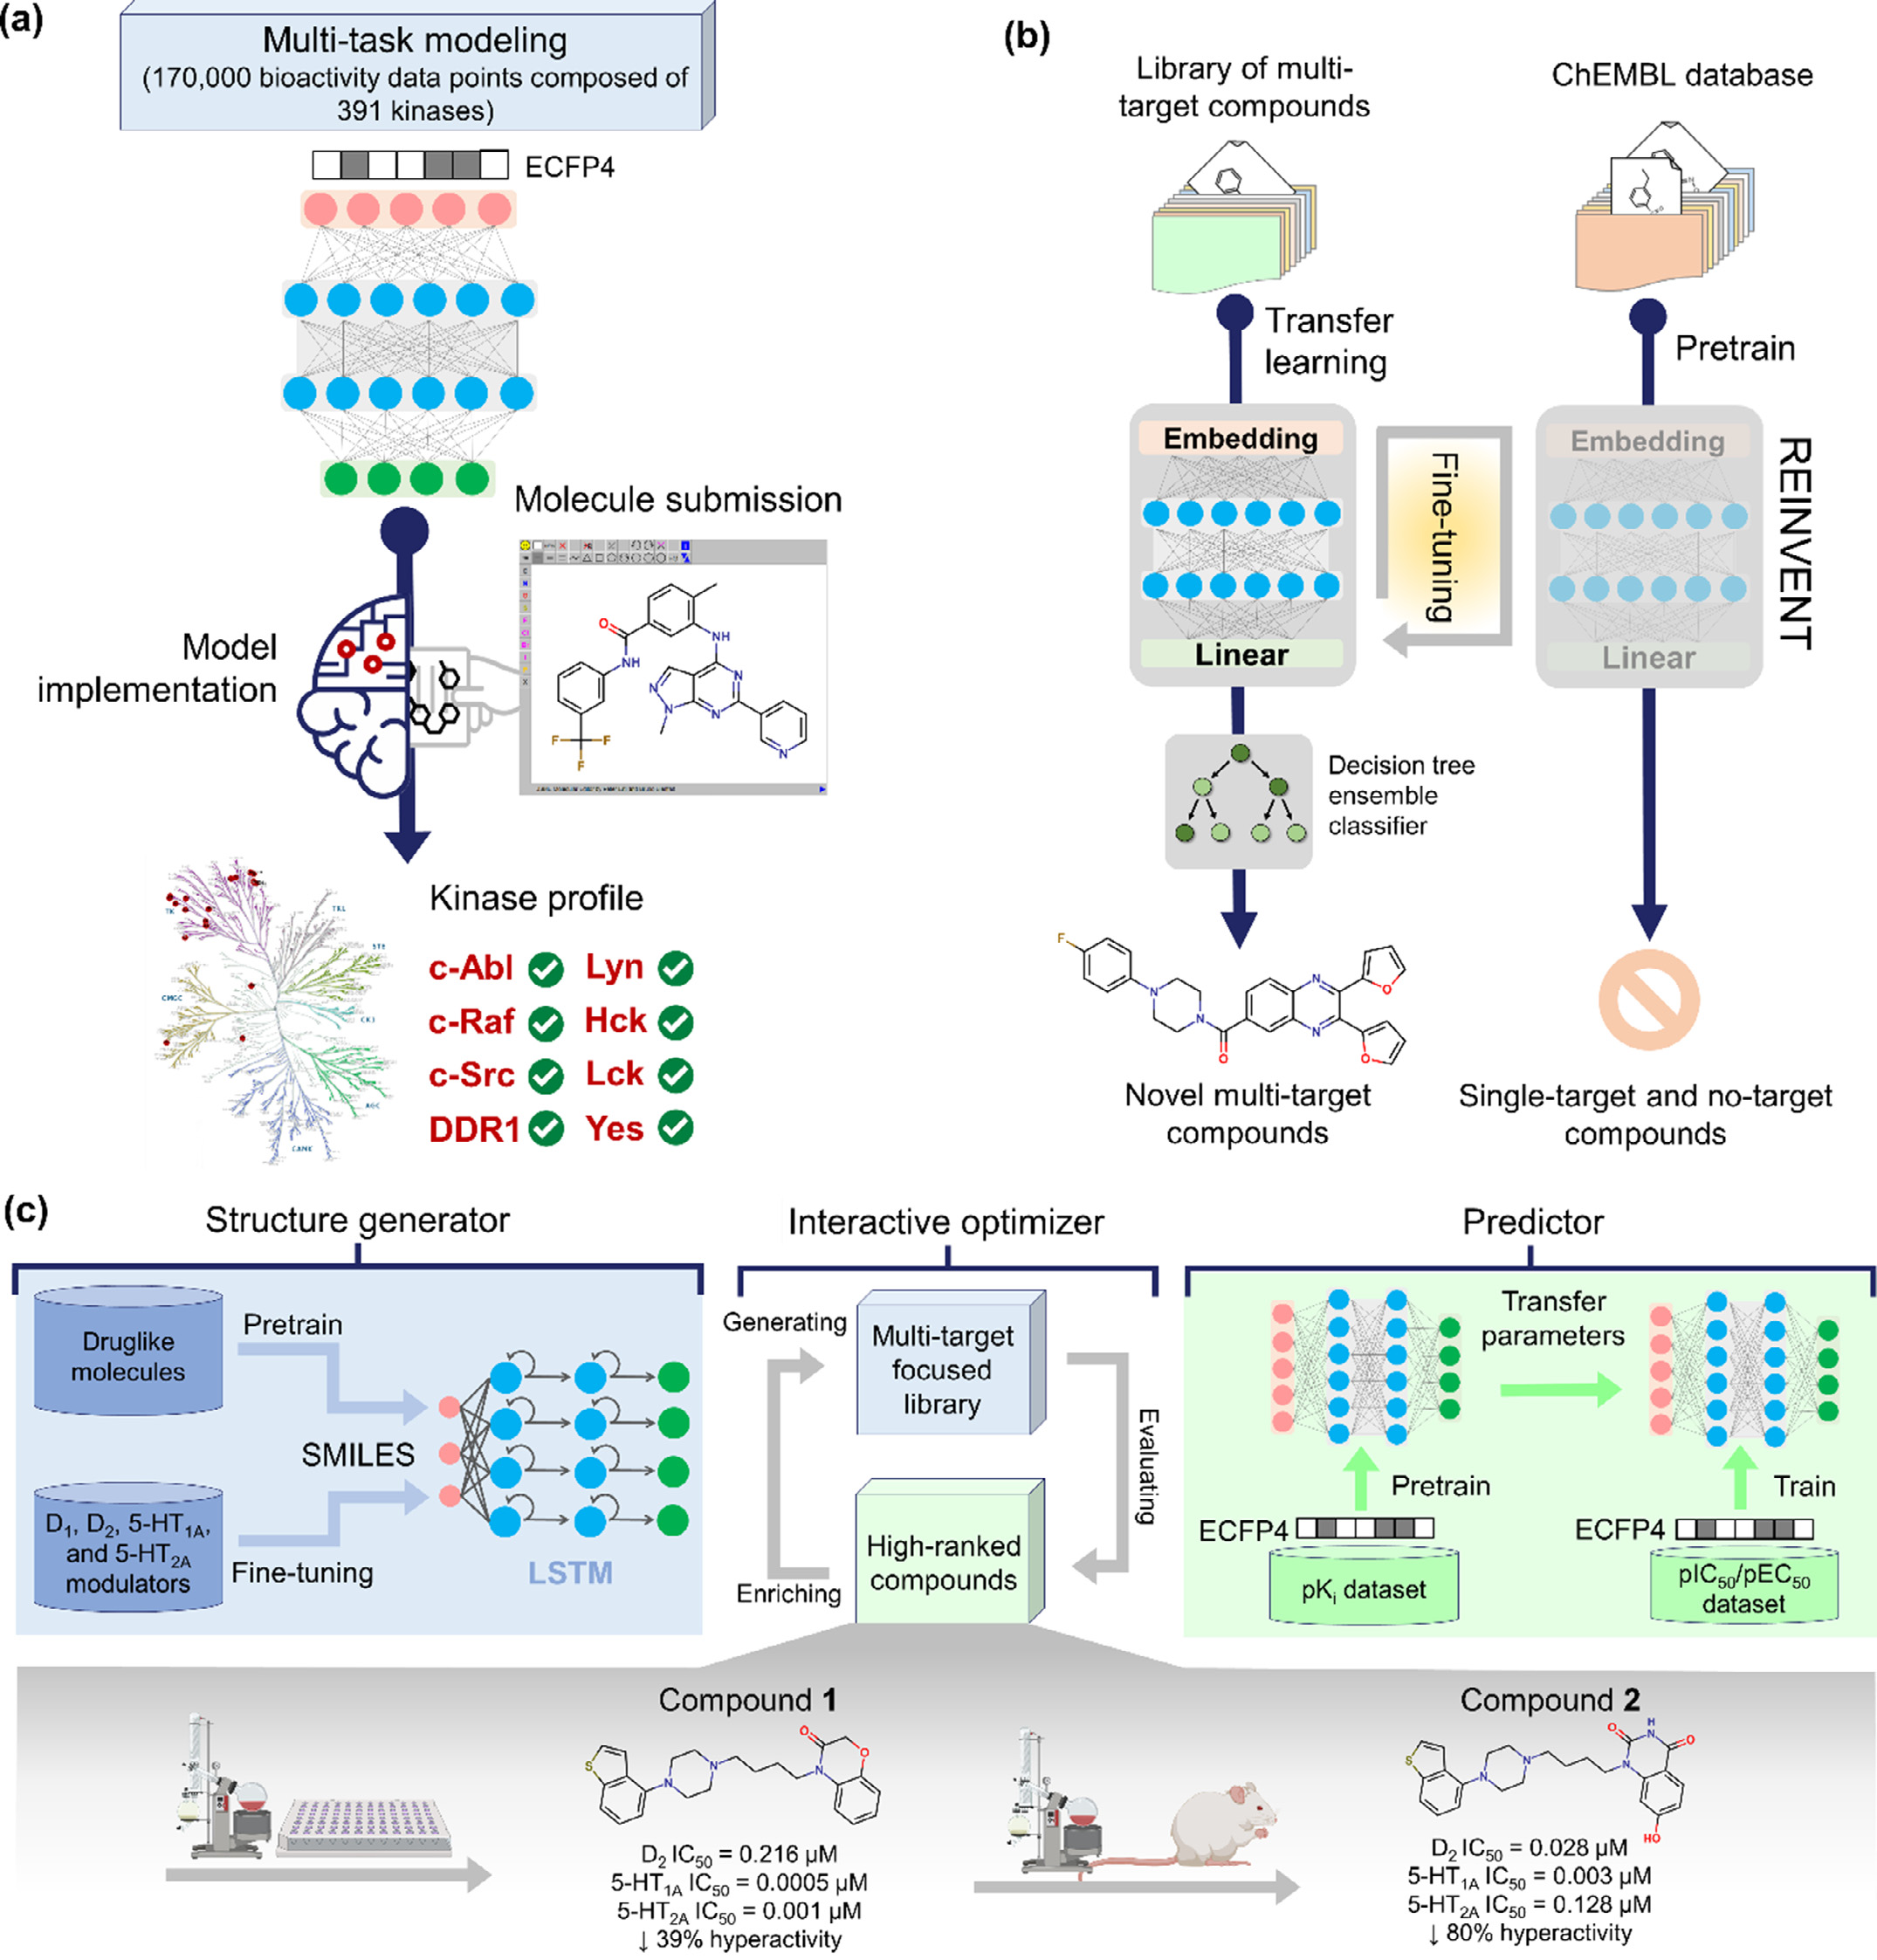

**Fig.5.**Examplesofautomateddeeplearning(DL)systemsexploredinmulti-targetdrugdiscovery.**(a)**TheworkflowofKinomeX,awebapplicationfortheprediction ofmulti-targetkinaseinhibitors;**(b)**Fine-tuningREINVENTgenerativeneuralnetworkforthe*denovo*designofmulti‑targetcompounds;and**(c)**Automated*denovo* designandoptimizationofmulti-targetleadcompoundswithantipsychoticactivitythroughtheintegrationofadeepgenerativenetworkandamulti-taskdeep neuralnetwork(MTL-DNNs).

compounds.Thisgenerativemodelwaspre-trainedusingRNNwithtwo stackedLSTMlayersbyalargesetofdrug-likecompoundsintheSMILES format.Then,thepre-trainedmodelwasfine-tunedusingasmalllibrary ofcompoundswithexperimentaldataagainsttheD1,D2,5-HT1A,and5 HT2Areceptors.Inparallel,anMTL-DNNsusingECFP4(Fig.5c)finger-printsasinputswasemployedtodeveloparegressionmodelforpredict-ingtheactivityofgeneratedcompoundsinthecontextoftheD1,D2,5-HT1A,and5HT2Areceptors[123].Duringthisprocess,atransferlearn-

8

*J.T.Moreira-Filho,M.F.B.daSilva,J.V.V.B.Borbaetal.*

systemhassuccessfullygeneratednewcompoundswithdesiredmulti-targetactivities.Amongthesenewcompounds,thehigh-rankingcom-pound1demonstratedpotentactivityagainstD2(IC50=0.216μM), 5-HT1A(IC50=0.0005μM),and5-HT2A(IC50=0.001μM)receptors inbiochemicalexperiments.Thestructuraloptimizationofcompound1 basedontheMTL-DNNsalsoledtothediscoveryofcompound2,which notonlyexhibitedamulti-targetprofilebutalsoshowedapotentan-tipsychoticeffectinmice(80%hyperactivityreduction)withlowpo-tentialforcatalepsyandsedation[123].

*3.2.1.Multi-objectiveoptimizationproblems*   
 ThedrugdiscoveryliteratureisriddledwithMOOapproachesto addressmulti-targetoptimizationproblems.Despitemanyofwhichare labeled“multi-objective”,thelinebetweenmulti-andsingle-objective molecularoptimizationisquiteblurred[124,125].TheMOOrefersto findingtheoptimalsolutionvaluesofmorethanonedesiredtarget. ThemotivationforusingtheMOOisthatoptimizationrequirestrivial equations,whichsimplifiestheproblem[125].TheequationoftheMOO problemisdefinedasfollows:

*𝑚𝑖𝑛*∕*𝑚𝑎𝑥𝑓*1(*𝑥*)*,𝑓*2(*𝑥*)*,...𝑓𝑛*(*𝑥*)

subjectto∶*𝑥*∈ *𝑈*  (2)

where*n*isthenumberofobjectivefunctions,*U*isfeasibleset,*x*isso-lution,*𝑓𝑛*(*𝑥*)isthe*n*thobjectivefunction,andmin/maxiscombined objectoperations[125].

AMOOtaskalwaysbeginswithsomestatementofdesiredproper-ties.First,thechemicalandbiologicalpropertiesmustbeconvertedto mathematicalobjectives.Ifmorethanoneobjectiveexists,theymustei-therbetreatedwithanappropriatemulti-objectiveformulation[124]. Inthissection,weexploretwooftheseMOOformulationsindetail, namelyscalarizationandParetomethod.Anin-depthdiscussionofMOO methodsindrugdiscoveryisprovidedbyFormerandColey[124]. Thescalarizationmethodreducesthemulti-objectiveoptimization problemintoasinglescalarvectorfunctionasfollows:

*𝐹*(*𝑥*)=*𝑤*1*𝑓*1(*𝑥*)+*𝑤*2*𝑓*2(*𝑥*)+… +*𝑤𝑛𝑓𝑛*(*𝑥*) (3)

where*n*isthenumberofobjectivefunctions,*𝐹*(*𝑥*)isacombinedfitness function,*x*isasolution,*𝑓𝑛*(*𝑥*)isthe*n*thobjectivefunction,andwisa constantweightfor*𝐹*(*𝑥*)[126].Theweightofanobjectivefunctionwill determinethesolutionofthefitnessfunctionandshowtheperformance priority.Forexample,ifalargeweightisgiventoanobjectivefunction, itwillhaveprioritycomparedtotheoneswithasmallerweight[126]. Incontrasttoscalarization,theParetomethoddiscoversasetofso-lutionsthatrevealthetrade-offsbetweenobjectiveswithoutachoice ofanyweightingfactorofimportanceforthecompetingobjectives [124,125].TheParetooptimizationcanbewrittenasfollows:

*𝑓*1*,𝑜𝑝𝑡*=min*𝑓*1(*𝑥*)

*𝑓*2*,𝑜𝑝𝑡*=min*𝑓*2(*𝑥*)

*.*  (4)

*.*

*𝑓𝑛,𝑜𝑝𝑡*=max*𝑓𝑛*(*𝑥*)

where*n*isthenumberofobjectivefunctions,*𝑓𝑛*(*𝑥*)isthe*n*thobjective function,*x*isasolution,andmin/maxisthethresholdofthe*n*thobjec-tive.Meanwhile,the*𝑓*1*,𝑜𝑝𝑡*e*𝑓*2*,𝑜𝑝𝑡*arethefirsttwofunctionsoftheset optimalsolutionspacethatminimizetheobjectivefunctionsof*𝑓*1and *𝑓*2.Mathematically,theParetooptimizationkeepstheelementsofthe solutionvectorsindependentduringoptimization,andtheconceptof dominanceistheretodifferentiatethenon-dominatedanddominated solutions.Thegoodnessofasolutionisdeterminedbydominance.A solutioniscallednon-dominatedifnoneoftheobjectivefunctionscan beimprovedwithoutbeingdetrimentaltoatleastoneotherobjective. Thedominatedsolutionisusuallyachievedwhenanobjectivefunction canbeimprovedwithoutreducingtheremainingobjectivefunctions [124,125].

Inviewoftheabove,Paretooptimizationisconsideredthestandard goldMOOapproachfor*denovo*design[124].Despitethis,thereisa

9

*J.T.Moreira-Filho,M.F.B.daSilva,J.V.V.B.Borbaetal.*  *ArtificialIntelligenceintheLifeSciences3(2023)100055*

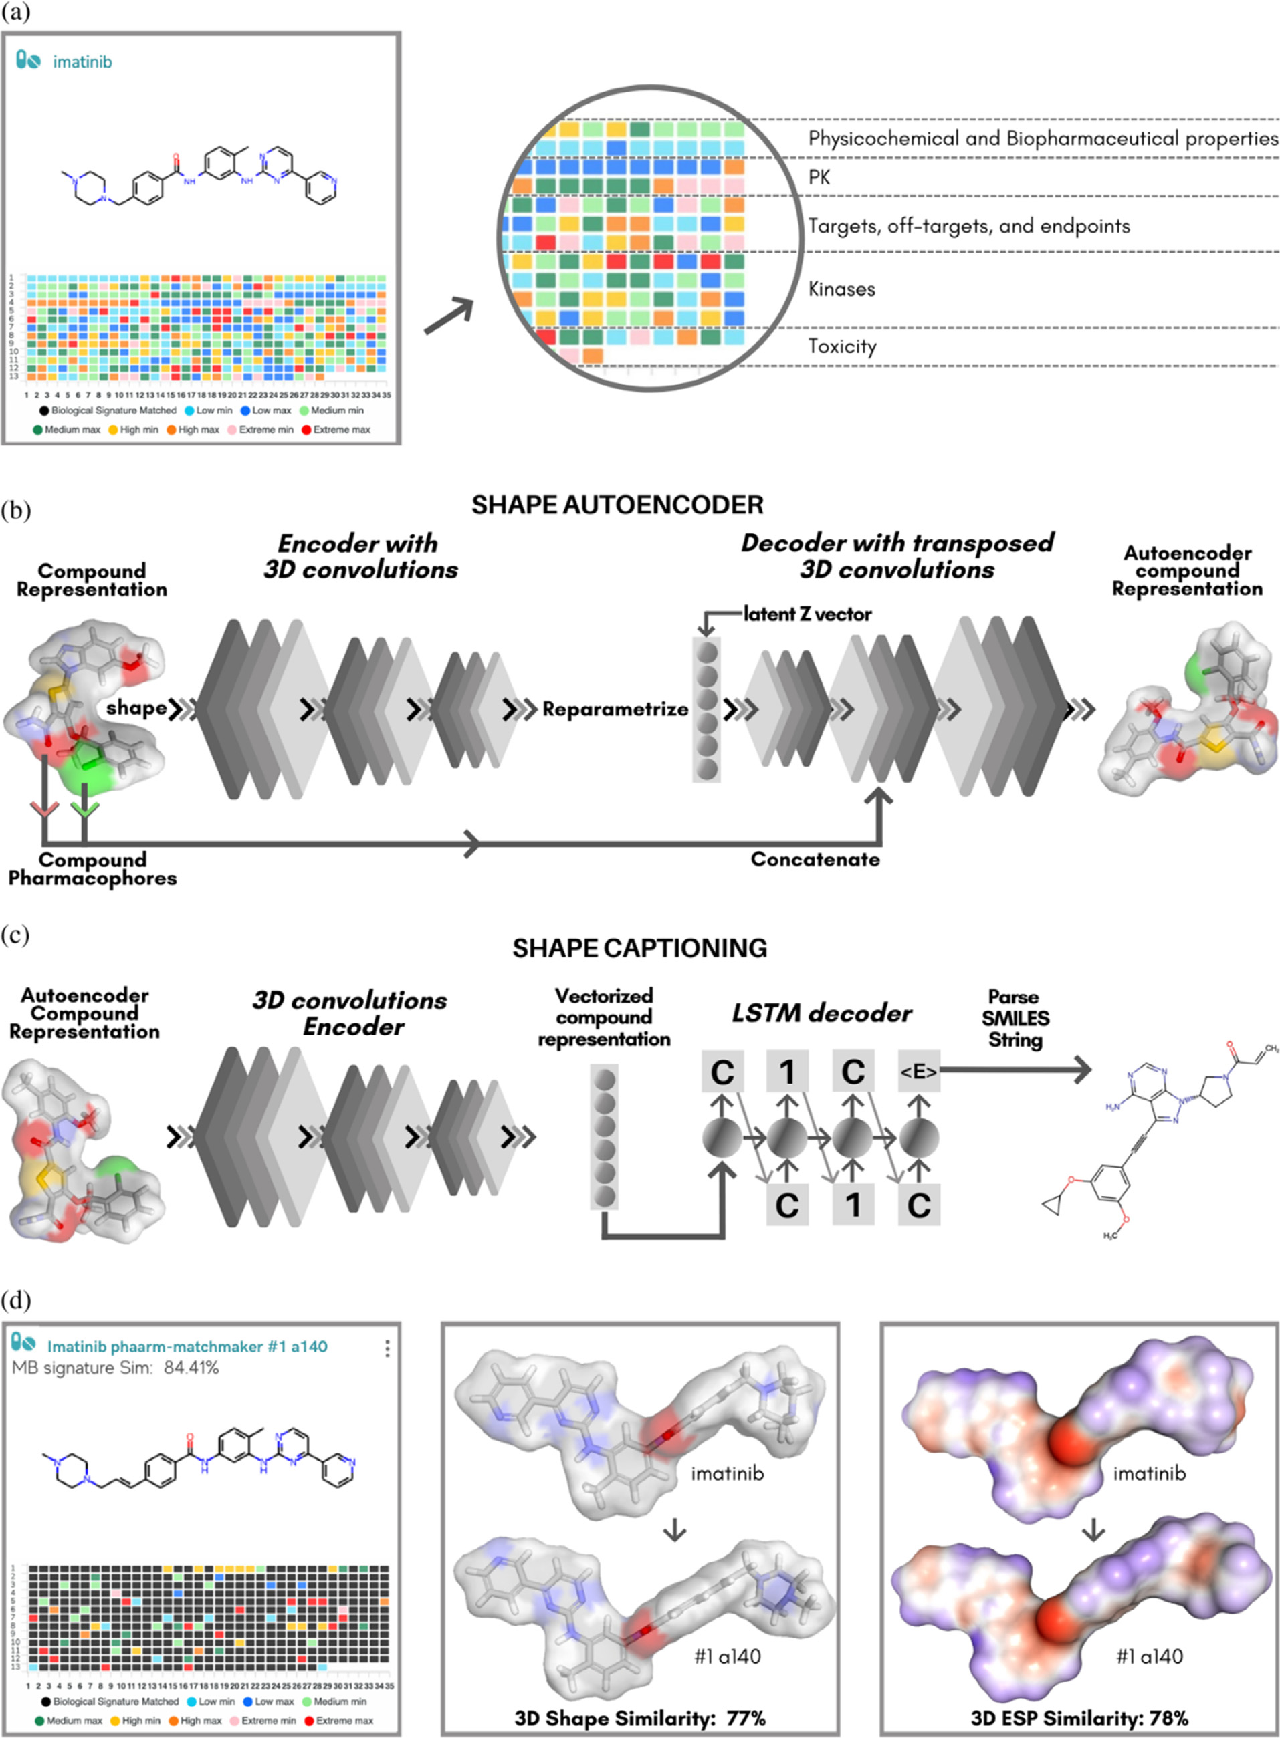

**Fig.6.**Deeplearningsystemsexploredinmulti-targetdrugdiscovery.**(a)**Usingimatinib,amarketedmultikinaseinhibitor,astemplatefortheevaluationofthe "molecularandbiologicalsignature"patternsbyPHAARMMatchMaker®;**(b)**scaffoldhoppingforthetarget(template)compoundusingthe*denovo*drugdesignwith 3DShape-BasedGenerativeModelingtoobtaintheAI-generatedcompounds(a-n)(FigureS1)withsimilarshapeandpharmacophorefeatures;**(c)**determinationof the3Dshapeandelectrostaticsimilarities(ESP-SimCarbo)forthedesignofsimilarcompounds;**(d)**generationofthe“molecularandbiologicalsignature” patterns fornewdesignedcompoundswithpredictedmultikinaseinhibition.Thecompoundssharearatherlargecommonsubstructure.

10

*J.T.Moreira-Filho,M.F.B.daSilva,J.V.V.B.Borbaetal.*

imatinibasatemplateforPHAARMMatchMakertoevaluateitsmolec-ularandbiologicalsignature.Then,weusedthe*denovo*DrugDesign withShape-BasedGenerativeModeling,inwhich3Dspatialinformation isincorporatedintwomajorphases:(i)ashapevariationalautoencoder employingCNNsencodesthecompoundrepresentation,and(ii)amix ofCNNsandLSTMnetworkscreateSMILESstrings.InFig.6,onecansee avisualrepresentationoftheprocedure.Withthenewapproach,which usesautoencodersandcaptioningnetworkstovarymoleculesstarting fromasinglevolumetricrepresentation,usingtheimatinibtemplate, compoundsweregeneratedbyAI(FigureS1a-n)withsimilarshapeand pharmacophorefeatures.

Partialchargesarecalculatedusinganeuralnetworkthatcombines B3LYP/6–31G∗∗calculationswithmulti-taskconstraintmessagepassing neuralnetworksforatomic/bondproperties.Thisallowsthecalculation ofhigh-qualityRESPsandshapescoresforanygivenstructurequerygiv-inganaccuratepredictiononwhetheritwillhavedesirablesweetspot properties[131–133].Finally,wegeneratedthe“molecularandbiolog-icalsignature” patternsfornewlydesignedcompoundswithpredicted multikinaseinhibition(FigureS2).Thecompoundssharearatherlarge commonsubstructure.Importantly,allcompoundsactivatedmorethan 10kinasesmodelswithstrongbindingaffinityandIC50.Weshowed compoundwithhighMBsignatureand3DShapeandESPsimilarities. Theshapeandelectrostaticpropertiesofmoleculesarewhatdeter-minehowsimilartwodifferentsubstancescanbe.Learningfrompast drugdiscoveryexperiences,thesecharacteristicsshouldthereforeplay amajorroleindeterminingwhichcomparisonmethodisused.Some-times,itishardtoreachthedesiredcomplexeffectwithone,onedrug (evenconsideringmagicshotgundrugs).Inthiscase,combiningthe drugswithdifferentmechanismsofactionand/orhittingavarietyof selectedtargetscouldserveasanalternativeapproach.Theapplication ofsuchapproachesinthediscoveryofsynergisticdrugcombinations againstSARS-CoV-2hasbeenreviewedelsewhere.

**5.Conclusion**

Historically,thediscoveryofnewchemicalentitieswithmulti-target profilehasbeenahugechallenge.Methodologically,theactivityofthese compoundsneedstobesimultaneouslyoptimizedtowardseveraltar-getswithdissimilarbindingpockets.However,intuitivelyfindinghid-denstructuralpatternsinchemicalaccessiblespaceofmulti-targetcom-poundsisquitedifficult.Toovercomethischallenge,MLandDLtools standoutascutting-edgedecisionsupportsystemstooptimizeresearch pipelinesandrevolutionizemulti-targetdrugdiscovery.SuchAIsystems areabletoidentifyandlearnfromcomplexstructuralpatternsandto designnewmolecularstructureswithdesiredmulti-targetprofilesata verylowcostandinatime-efficientmanner.However,manyofthese techniquesarecurrentlybeingevaluatedinthecontextofprospective drugdiscovery.Thus,onlyalimitednumberofstudiespresentexperi-mentalvalidationresults.Inthispaper,wehavehighlightedsomestud-iesshowingencouragingexperimentalresultsinspiredbyanautomated designofmulti-targetcompoundsusingdeepgenerativenetworksand MTL-DNNs.Fulldevelopmentofthesetoolswillrequireproject-oriented interdisciplinaryteamsthatcloselyintegratedatascience,synthesis,and biologicalevaluationtoguidethenextgenerationofmulti-targetdrugs.

**DeclarationofCompetingInterest**

Theauthorsdeclarethattheyhavenoknowncompetingfinancial interestsorpersonalrelationshipsthatcouldhaveappearedtoinfluence theworkreportedinthispaper.

R.C.B.isCTOofInsilicAllInc.Theotherauthorsdeclaretheyhave noactualorpotentialcompetingfinancialinterests.

**Dataavailability**

Nodatawasusedfortheresearchdescribedinthearticle.

11

*J.T.Moreira-Filho,M.F.B.daSilva,J.V.V.B.Borbaetal.*

[25]SzklarczykD,SantosA,vonMeringC,JensenLJ,BorkP,KuhnM.STITCH5: augmentingprotein–chemicalinteraction[networkswithtissue](https://doi.org/10.1093/nar/gkv1277)andaffinitydata. Nucleic.Acids.Res.2016;44:D380–4.doi[:10.1093/nar/gkv1277.](https://doi.org/10.1093/nar/gkv1277)

[26]ChangA,JeskeL,UlbrichS,HofmannJ,K[oblitzJ,SchomburgI,e](https://doi.org/10.1093/nar/gkv1277)tal.BRENDA,the elixircoredataresourcein2[021:newdevelopments](https://doi.org/10.1093/nar/gkaa1025)andupdates.Nucleic.Acids. Res.2021;49:D498–508.doi[:10.1093/nar/gkaa1025.](https://doi.org/10.1093/nar/gkaa1025)

[27]KarpPD,BillingtonR,Caspi[R,FulcherCA,Latendr](https://doi.org/10.1093/nar/gkaa1025)esseM,KothariA,etal.The biocyccollectionofm[icrobialgenomesand](https://doi.org/10.1093/bib/bbx085)metabolicpathways.BriefBioinform 2019;20:1085–93.doi[:10.1093/bib/bbx085.](https://doi.org/10.1093/bib/bbx085)

[28]WilliamsAJ,GrulkeC[M,EdwardsJ,McEac](https://doi.org/10.1093/bib/bbx085)hranAD,MansouriK,BakerNC,etal.

Thecomptoxchemistrydashboard:acomm[unitydataresourceforenvir](https://doi.org/10.1186/s13321-017-0247-6)onmental chemistry.JCheminform2017;9:1–27.doi[:10.1186/s13321-017-0247-6.](https://doi.org/10.1186/s13321-017-0247-6)

[29]LouDorneJ,JRichardson,KassG,Georgi[adisN,MonguidiM,Pasinato](https://doi.org/10.1186/s13321-017-0247-6)L,etal.

Editorial:openfoodtox:eFSA’sopensourcetoxicolo[gicaldatabaseonchemicalha](https://doi.org/10.2903/j.efsa.2017.e15011)z- ardsinfoodandfeed.EFSAJ2017;15:e15011.doi[:10.2903/j.efsa.2017.e15011.](https://doi.org/10.2903/j.efsa.2017.e15011) [30]ZarinDA,TseT,WilliamsRJ,Califf RM,Ide[NC.Theclinicaltrials.govr](https://doi.org/10.2903/j.efsa.2017.e15011)e- sult[sdatabase— Updatean](https://doi.org/10.1056/NEJMsa1012065)dkeyissues.N.Engl.J.Med.2011;364:852–60. doi[:10.1056/NEJMsa1012065.](https://doi.org/10.1056/NEJMsa1012065)

[31]Tho[rnCF,KleinTE,Altman](https://doi.org/10.1056/NEJMsa1012065)RB.Pharmacoge[nomicsandbioinfo](https://doi.org/10.2217/pgs.10.15)rmatics:phar- mGKB.Pharmacogenomics2010;11:501–5.doi[:10.2217/pgs.10.15.](https://doi.org/10.2217/pgs.10.15)

[32]ZhangW,PeiJ,LaiL[.Computationalmultitarget](https://doi.org/10.1021/acs.jcim.6b00491)[drugdesign.J.Ch](https://doi.org/10.2217/pgs.10.15)em.Inf.Model 2017;57:403–12.doi[:10.1021/acs.jcim.6b00491.](https://doi.org/10.1021/acs.jcim.6b00491)

[33]BajorathJ.Founda[tionsofdata-drivenmedi](https://doi.org/10.1021/acs.jcim.6b00491)cinalchemistry.FuturSciOA 2018;4:FSO320.doi[:10.4155/fsoa-2018-0057.](https://doi.org/10.4155/fsoa-2018-0057)

[34]SchneiderP,Walter[sWP,PlowrightAT,Sie](https://doi.org/10.4155/fsoa-2018-0057)rokaN,ListgartenJ,GoodnowRA, etal.Rethinkingdrug[designintheartificia](https://doi.org/10.1038/s41573-019-0050-3)l[intelli](https://doi.org/10.1038/s41573-019-0050-3)genceera.NatRevDrugDiscov 2020;19:353–64.doi[:10.1038/s41573-019-0050-3.](https://doi.org/10.1038/s41573-019-0050-3)

[35]Moreira-FilhoJT,Silv[aAC,DantasRF,GomesBF,S](https://doi.org/10.1038/s41573-019-0050-3)ouzaNetoLR,Brandao-NetoJ, etal.Schistosomiasisdrugdiscoveryinthe[eraofautomationandartific](https://doi.org/10.3389/fimmu.2021.642383)ialintelli-gence.Front.Immunol.2021;12:1–29.doi[:10.3389/fimmu.2021.64238](https://doi.org/10.3389/fimmu.2021.642383)3[.](https://doi.org/10.3389/fimmu.2021.642383)

[36]LiD,HuJ,ZhangL,LiL,YinQ,ShiJ,et[al.DeepLearningandMachin](https://doi.org/10.3389/fimmu.2021.642383)eIntelli-gence:NewComputationalModelingTechniquesforDiscoveryoftheCombination RulesandPharmacodynamicChara[cteristicsofTraditionalChinese](https://doi.org/10.1016/j.ejphar.2022.175260)Medicine.Eur JPharmacol2022;933:175260.doi[:10.1016/j.ejphar.2022.175260.](https://doi.org/10.1016/j.ejphar.2022.175260)

[37]CherkasovA,MuratovEN,Fourch[esD,VarnekA,BaskinII,Cr](https://doi.org/10.1016/j.ejphar.2022.175260)oninM,etal.

QSARmodeling:where[haveyoubeen?wher](https://doi.org/10.1021/jm4004285)eareyougoingto?J.Med.Chem. 2014;57:4977–5010.doi[:10.1021/jm4004285.](https://doi.org/10.1021/jm4004285)

[38]EkinsS,PuhlAC,ZornK[M,LaneTR,RussoDP](https://doi.org/10.1021/jm4004285),KleinJJ,etal.Exploitingmachine learnin[gforend-to-enddrugdiscover](https://doi.org/10.1038/s41563-019-0338-z)yanddevelopment.Nat.Mater.2019;18:435–41.doi[:10.1038/s41563-019-0338-z.](https://doi.org/10.1038/s41563-019-0338-z)

[39]Réda[C,KaufmannE.Delahay](https://doi.org/10.1038/s41563-019-0338-z)e-DuriezA.machinelearningapplica-tion[sindrugdevelopment.](https://doi.org/10.1016/j.csbj.2019.12.006)ComputStructBiotechnolJ2020;18:241–52. doi[:10.1016/j.csbj.2019.12.006.](https://doi.org/10.1016/j.csbj.2019.12.006)

[40]Va[mathevanJ,ClarkD,Czodro](https://doi.org/10.1016/j.csbj.2019.12.006)wskiP,DunhamI,FerranE,LeeG,etal.Applica-tionsofmachinelear[ningindrugdiscoveryanddev](https://doi.org/10.1038/s41573-019-0024-5)elopment.NatRevDrugDiscov 2019;18:463–77.doi[:10.1038/s41573-019-0024-5.](https://doi.org/10.1038/s41573-019-0024-5)

[41]MitchellJBO.Machi[nelearningmethodsinchem](https://doi.org/10.1038/s41573-019-0024-5)[oinformatic](https://doi.org/10.1002/wcms.1183)s.WileyInterdiscip RevComputMolSci2014;4:468–81.doi[:10.1002/wcms.1183.](https://doi.org/10.1002/wcms.1183)

[42]HanschC,MaloneyPP,FujitaT,Muir[RM.Correlationofb](https://doi.org/10.1002/wcms.1183)iologicalactivityof phenoxyaceticacidswithham[mettsubstituentcon](https://doi.org/10.1038/194178b0)stantsandpartitioncoefficients. Nature1962;194:178–80.doi[:10.1038/194178b0.](https://doi.org/10.1038/194178b0)

[43]PatelL,ShuklaT,HuangX,Us[seryDW,WangS.M](https://doi.org/10.1038/194178b0)[achinelearningmeth](https://doi.org/10.3390/molecules25225277)odsindrug discovery.Molecules2020;25:5277.doi[:10.3390/molecules25225277.](https://doi.org/10.3390/molecules25225277)

[44]ZhangL,TanJ,HanD,ZhuH.Fro[mmachinelearningtodee](https://doi.org/10.3390/molecules25225277)plearning: progressinmachine[intelligenceforrationaldrug](https://doi.org/10.1016/j.drudis.2017.08.010)discovery.DrugDiscovToday 2017;22:1680–5.doi[:10.1016/j.drudis.2017.08.010.](https://doi.org/10.1016/j.drudis.2017.08.010)

[45]MaltarolloVG,Krone[nbergerT,EspinozaGZ,Olivei](https://doi.org/10.1016/j.drudis.2017.08.010)raPR,HonorioKM.Advances withsupportvector[machinesfornoveldrugdiscovery](https://doi.org/10.1080/17460441.2019.1549033).ExpertOpinDrugDiscov 2019;14:23–33.doi[:10.1080/17460441.2019.1549033.](https://doi.org/10.1080/17460441.2019.1549033)

[46]Jiménez-LunaJ,Gr[isoniF,WeskampN,SchneiderG](https://doi.org/10.1080/17460441.2019.1549033).Artificialintelligencein drugdiscovery:recen[tadvancesandfutureperspectives.](https://doi.org/10.1080/17460441.2021.1909567)ExpertOpinDrugDiscov 2021;16:949–59.doi[:10.1080/17460441.2021.1909567.](https://doi.org/10.1080/17460441.2021.1909567)

[47]SvetnikV,LiawA,To[ngC,ChristopherCulbersonJ,Sher](https://doi.org/10.1080/17460441.2021.1909567)idanRP,FeustonBP.Ran- domforest:aclassificationandregressiontoolforcompound[classificatio](https://doi.org/10.1021/ci034160g)n[andqsa](https://doi.org/10.1021/ci034160g)r modeling.J.Chem.Inf.Comput.Sci.2003;43:1947–58.doi[:10.1021/ci034160g.](https://doi.org/10.1021/ci034160g) [48]Sharma S, Sharma D. Intelligently applying a[rtificia](https://doi.org/10.1021/ci034160g)l [intelligenc](https://doi.org/10.1021/ci034160g)e in [chemoinformatics.](https://doi.org/10.2174/1568026619666181120150938)  [Curr.](https://doi.org/10.2174/1568026619666181120150938)  [Top.](https://doi.org/10.2174/1568026619666181120150938)  Med. Chem. 2018;18:1804–26. doi[:10.2174/1568026619666181120150938.](https://doi.org/10.2174/1568026619666181120150938)

[49]Lav[ecchiaA.Machine-learningapproachesin](https://doi.org/10.2174/1568026619666181120150938)dru[gdiscovery:methodsandapp](https://doi.org/10.1016/j.drudis.2014.10.012)li- cations.DrugDiscovToday2015;20:318–31.doi[:10.1016/j.drudis.2014.10.012.](https://doi.org/10.1016/j.drudis.2014.10.012) [50]PedryczW,SosnowskiZA.Thedesignofdeci[siontreesintheframework](https://doi.org/10.1016/j.drudis.2014.10.012)of granulardataandthe[irapplicationtosoftwarequality](https://doi.org/10.1016/S0165-0114(00)00118-4)models.FuzzySetsSyst. 2001;123:271–90.doi[:10.1016/S0165-0114(00)00118-4.](https://doi.org/10.1016/S0165-0114(00)00118-4)

[51]Kingsfo[rdC,Salzberg](https://doi.org/10.1038/nbt0908-1011)[SL.Whataredecisiontrees?Nat.Bi](https://doi.org/10.1016/S0165-0114(00)00118-4)otechnol.2008;26:1011– 12.doi[:10.1038/nbt0908-1011.](https://doi.org/10.1038/nbt0908-1011)

[52]Podgor[elecV,KokolP,StiglicB](https://doi.org/10.1038/nbt0908-1011),RozmanI.Decisio[ntrees:anoverviewandthe](https://doi.org/10.1023/A:1016409317640)ir [useinmedicine.J.Med.Syst.2002;26:445–63.doi](http://refhub.elsevier.com/S2667-3185(22)00025-3/sbref0053)[:10.1023/A:1016409317640.](https://doi.org/10.1023/A:1016409317640) [53][BreimanL.Baggingpredictions.MachLearn1996;2](http://refhub.elsevier.com/S2667-3185(22)00025-3/sbref0053)[4:123–40.](https://doi.org/10.1023/A:1016409317640)

[54][Carracedo-ReboredoP,Liñares-BlancoJ,Rodríguez-Ferná](http://refhub.elsevier.com/S2667-3185(22)00025-3/sbref0053)ndezN,CedrónF, NovoaFJ,CarballalA,etal.Areviewonmachinelearningapproaches and[trendsindrugdiscovery.](https://doi.org/10.1016/j.csbj.2021.08.011)ComputStructBiotechnolJ2021;19:4538–58. doi[:10.1016/j.csbj.2021.08.011.](https://doi.org/10.1016/j.csbj.2021.08.011)

[55]Mu[solfAM,HolzingerER,Malle](https://doi.org/10.1016/j.csbj.2021.08.011)yJD,Bailey-WilsonJE.Whatmakesagoodpredic-tion?featureimportanceandbegin[ningtoopentheblackboxofm](https://doi.org/10.1007/s00439-021-02402-z)achinelearning ingenetics.Hum.Genet.2021.doi[:10.1007/s00439-021-02402-z.](https://doi.org/10.1007/s00439-021-02402-z)

12

*J.T.Moreira-Filho,M.F.B.daSilva,J.V.V.B.Borbaetal.*

[88]KrennM.,AiQ.,BarthelS.,CarsonN.,FreiA.,FreyN.C.,etal.SELFIESandthefu- tureofmolecularstringrepresentations.2022.doi:10.1016/j.patter.2022.100588 [89]HochreiterS,Schm[idhuberJ.Longshort-ter](https://doi.org/10.1162/neco.1997.9.8.1735)mmemory.NeuralComput. 1997;9:1735–80.doi[:10.1162/neco.1997.9.8.1735.](https://doi.org/10.1162/neco.1997.9.8.1735)

[90]ChungJ.,Gulcehre[C.,ChoK.,BengioY.E](https://doi.org/10.1162/neco.1997.9.8.1735)mpiricalevaluationofgated [recurrentneuralnetworks](http://arxiv.org/abs/1412.3555)onsequencemodeling.2014.Available: <http://arxiv.org/abs/1412.3555>  
[91][Greff K](http://arxiv.org/abs/1412.3555),[SrivastavaRK,Koutni](http://arxiv.org/abs/1412.3555)kJ,SteunebrinkBR,SchmidhuberJ.LSTM:a sea[rchspaceodyssey.IEEETransN](https://doi.org/10.1109/TNNLS.2016.2582924)euralNetworksLearnSyst2017;28:2222–32. doi[:10.1109/TNNLS.2016.2582924.](https://doi.org/10.1109/TNNLS.2016.2582924)

[92]Cho[K.,vanMerrienboerB.,B](https://doi.org/10.1109/TNNLS.2016.2582924)ahdanauD.,BengioY.Ontheproperties [ofneuralmachinetranslation:](http://arxiv.org/abs/1409.1259)encoder-decoderapproaches.2014.Available: <http://arxiv.org/abs/1409.1259>  
[93][Veličković P.,CucurullG.,Casan](http://arxiv.org/abs/1409.1259)[ovaA.,RomeroA.,Liò P.,Bengio](http://arxiv.org/abs/1710.10903)Y.Graphatten- tionnetworks.2017.Available:<http://arxiv.org/abs/1710.10903>  
[94]GilmerJ.,SchoenholzS.S.,Riley[P.F.,VinyalsO.,DahlG.E.Neural](http://arxiv.org/abs/1710.10903)[message](http://arxiv.org/abs/1704.01212)passing forquantumchemistry.2017.Available:<http://arxiv.org/abs/1704.01212>[95]GaudeletT,DayB,JamasbAR,SomanJ,[RegepC,LiuG,etal.Utilizinggra](http://arxiv.org/abs/1704.01212)phma- chinele[arningwithindrugdisc](https://doi.org/10.1093/bib/bbab159)overyanddevelopment.BriefBioinform2021;22:1– 22.doi[:10.1093/bib/bbab159.](https://doi.org/10.1093/bib/bbab159)

[96]ZengX[,TuX,LiuY,FuX,Su](https://doi.org/10.1093/bib/bbab159)Y.Towardbetterdr[ugdiscoverywithknowled](https://doi.org/10.1016/j.sbi.2021.09.003)ge graph.Curr.Opin.Struct.Biol.2022;72:114–26.doi[:10.1016/j.sbi.2021.09.003.](https://doi.org/10.1016/j.sbi.2021.09.003) [97]ZhangZ,ChenL,ZhongF,WangD,JiangJ,ZhangS[,etal.Graphneuralnetwo](https://doi.org/10.1016/j.sbi.2021.09.003)rk app[roachesfordrug-targetinter](https://doi.org/10.1016/j.sbi.2021.102327)actions.Curr.Opin.Struct.Biol.2022;73:102327. doi[:10.1016/j.sbi.2021.102327.](https://doi.org/10.1016/j.sbi.2021.102327)

[98]Sun[M,ZhaoS,GilvaryC,Ele](https://doi.org/10.1016/j.sbi.2021.102327)mentoO,ZhouJ,WangF.Graphconvolutional networksforcompu[tationaldrugdevelo](https://doi.org/10.1093/bib/bbz042)pmentanddiscovery.BriefBioinform 2020;21:919–35.doi[:10.1093/bib/bbz042.](https://doi.org/10.1093/bib/bbz042)

[99]Méndez-LucioO,Ah[madM,delRio-Chan](https://doi.org/10.1093/bib/bbz042)onaEA,WegnerJK.Ageometricdeep learningapproachtopredictbi[ndingconformationsofbioact](https://doi.org/10.1038/s42256-021-00409-9)ivemolecules.Nat [MachIntell2021;3:1033–9.doi](http://refhub.elsevier.com/S2667-3185(22)00025-3/sbref0100)[:10.1038/s42256-021-00409-9.](https://doi.org/10.1038/s42256-021-00409-9)

[[100]UnterthinerT,MayrA,Klamba](http://refhub.elsevier.com/S2667-3185(22)00025-3/sbref0100)[uerG,SteijaertM,WegnerJ,](https://doi.org/10.1038/s42256-021-00409-9)[CeulemansH,etal.](http://refhub.elsevier.com/S2667-3185(22)00025-3/sbref0100)

[Deeplearningasanopportunityinvirtualscreening.AdvNeuralInfProcessSyst 2014;27:1–9.](http://refhub.elsevier.com/S2667-3185(22)00025-3/sbref0100)

[[101]XuY,MaJ,LiawA,SheridanRP,SvetnikV.Demystifyingmultitaskdeepneu-](http://refhub.elsevier.com/S2667-3185(22)00025-3/sbref0100)ralnetworksforquantit[ativestructure-activityrela](https://doi.org/10.1021/acs.jcim.7b00087)tionships.J.Chem.Inf.Model. 2017;57:2490–504.doi[:10.1021/acs.jcim.7b00087.](https://doi.org/10.1021/acs.jcim.7b00087)

[102]RamsundarB,LiuB,[WuZ,VerrasA,TudorM,](https://doi.org/10.1021/acs.jcim.7b00087)SheridanRP,etal.Ismulti-task[deeplearningpracticalfo](https://doi.org/10.1021/acs.jcim.7b00146)rpharma?J.Chem.Inf.Model.2017;57:2068–76. doi[:10.1021/acs.jcim.7b00146.](https://doi.org/10.1021/acs.jcim.7b00146)

[103]Per[eraV,ChungT,KollarT,](https://doi.org/10.1021/acs.jcim.7b00146)StrubellE.Multi-Tasklearningforparsingthe ale[xameaningrepresentation](https://doi.org/10.1609/aaai.v32i1.12019)language.ProcAAAIConfArtifIntell2018;32. doi[:10.1609/aaai.v32i1.12019.](https://doi.org/10.1609/aaai.v32i1.12019)

[104]Che[nY,YuJ,ZhaoY,ChenJ,](https://doi.org/10.1609/aaai.v32i1.12019)DuX.Task’schoice:pruni[ng-basedfeatureshar](https://doi.org/10.3390/e24030432)ing (PBFS)formulti-tasklearning.Entropy2022;24:432.doi[:10.3390/e24030432.](https://doi.org/10.3390/e24030432)

[105]SanhV.,WolfT.,RuderS.Ahierarchicalm[ulti-taskappr](http://arxiv.org/abs/1811.06031)[oachforlearningemb](https://doi.org/10.3390/e24030432)ed- dingsfromsemantictasks.2018.Available:<http://arxiv.org/abs/1811.06031>[106]HashimotoK,XiongC,TsuruokaY,Socher[R.Ajointmany-taskmodel:growi](http://arxiv.org/abs/1811.06031)nga neuralnetworkformultiplenlptasks.In:Proceedingsofthe2017conferenceon empiricalmethodsinnaturallanguageprocessing.Stroud[sburg,PA,USA:Associa-](https://doi.org/10.18653/v1/D17-1206) tionforComputationalLinguistics;2017.p.1923–33.doi[:10.18653/v1/D17-1206.](https://doi.org/10.18653/v1/D17-1206) [107]SunT.,ShaoY.,LiX.,LiuP.,YanH.,QiuX[.,etal.Learn](http://arxiv.org/abs/1911.05034)[ingsparsesharingarchi](https://doi.org/10.18653/v1/D17-1206)- tecturesformultipletasks.2019.Available:<http://arxiv.org/abs/1911.05034>[108]SunT,ShaoY,LiX,LiuP,YanH,Qiu[X,etal.Learningsparsesharing](http://arxiv.org/abs/1911.05034)ar- chit[ecturesformultipletasks](https://doi.org/10.1609/aaai.v34i05.6424).ProcAAAIConfArtifIntell2020;34:8936–43. doi[:10.1609/aaai.v34i05.6424.](https://doi.org/10.1609/aaai.v34i05.6424)

[109]Tan[gH,LiuJ,ZhaoM,GongX.](https://doi.org/10.1609/aaai.v34i05.6424)Progressivelayeredextraction(PLE):anovelmulti-tasklearning(MTL)modelforpersonalizedrecommendations.In:FourteenthACM Con[ferenceonRecommenderSy](https://doi.org/10.1145/3383313.3412236)stems.NewYork,NY,USA:ACM;2020.p.269–78. doi[:10.1145/3383313.3412236.](https://doi.org/10.1145/3383313.3412236)

[110]LiZ[,LiX,LiuX,FuZ,XiongZ,](https://doi.org/10.1145/3383313.3412236)WuX,etal.KinomeX:awebapplicationforpre-dictingkinome-widepolypharmacol[ogyeffec](https://doi.org/10.1093/bioinformatics/btz519)t[ofsmallmolecules.W](https://doi.org/10.1093/bioinformatics/btz519)renJ,editor. Bioinformatics2019;35:5354–6.doi[:10.1093/bioinformatics/btz519.](https://doi.org/10.1093/bioinformatics/btz519)

[111]LiX,LiZ,WuX,XiongZ,YangT,[FuZ,etal.Deeplearningenhan](https://doi.org/10.1093/bioinformatics/btz519)cingkinome-widepolypharmacologyprofiling:mo[delconstructionandexperiment](https://doi.org/10.1021/acs.jmedchem.9b00855)validation. J.Med.Chem.2020;63:8723–37.doi[:10.1021/acs.jmedchem.9b00855.](https://doi.org/10.1021/acs.jmedchem.9b00855)

*ArtificialIntelligenceintheLifeSciences3(2023)100055*

[112]PolykovskiyD,ZhebrakA,Sanchez-LengelingB,GolovanovS,TatanovO, BelyaevS,etal.Molecularsets(MOSES):abenchmarkingplatform for[moleculargeneration](https://doi.org/10.3389/fphar.2020.565644)models.FrontPharmacol2020;11:565644. doi[:10.3389/fphar.2020.565644.](https://doi.org/10.3389/fphar.2020.565644)

[113]Bla[schkeT,Arús-PousJ,ChenH,](https://doi.org/10.3389/fphar.2020.565644)MargreitterC,TyrchanC,EngkvistO,etal.REIN-VE[NT2.0:anaitoolfordenovo](https://doi.org/10.1021/acs.jcim.0c00915)drugdesign.J.Chem.Inf.Model2020;60:5918–22. doi:[10.1021/acs.jcim.0c00915.](https://doi.org/10.1021/acs.jcim.0c00915)

[114]Bro[wnN,FiscatoM,SeglerM](https://doi.org/10.1021/acs.jcim.0c00915)HS,VaucherAC.GuacaMol:benchmarkingmod-els[fordenovomoleculard](https://doi.org/10.1021/acs.jcim.8b00839)esign.J.Chem.Inf.Model2019;59:1096–108. doi[:10.1021/acs.jcim.8b00839.](https://doi.org/10.1021/acs.jcim.8b00839)

[115]Me[yersJ,FabianB,BrownN.](https://doi.org/10.1021/acs.jcim.8b00839)[Denovomoleculardesignan](https://doi.org/10.1016/j.drudis.2021.05.019)dgenerativemodels. DrugDiscovToday2021.doi[:10.1016/j.drudis.2021.05.019.](https://doi.org/10.1016/j.drudis.2021.05.019)

[116]MartinelliDD.Generative[machinelearningford](https://doi.org/10.1016/j.drudis.2021.05.019)enovodrugdis-cov[ery:asystematicreview.Com](https://doi.org/10.1016/j.compbiomed.2022.105403)put.Biol.Med.2022;145:105403. doi[:10.1016/j.compbiomed.2022.105403.](https://doi.org/10.1016/j.compbiomed.2022.105403)

[117]Wa[ngM,WangZ,SunH,WangJ,ShenC,](https://doi.org/10.1016/j.compbiomed.2022.105403)WengG,etal.Deeplearningapproaches for[denovodrugdesign:ano](https://doi.org/10.1016/j.sbi.2021.10.001)verview.Curr.Opin.Struct.Biol.2022;72:135–44. doi:[10.1016/j.sbi.2021.10.001.](https://doi.org/10.1016/j.sbi.2021.10.001)

[118]Seg[lerMHS,KogejT,TyrchanC](https://doi.org/10.1016/j.sbi.2021.10.001),WallerMP.Generatingfocusedmoleculelibraries for[drugdiscoverywithrecurren](https://doi.org/10.1021/acscentsci.7b00512)tneuralnetworks.ACSCentSci2018;4:120–31. doi:[10.1021/acscentsci.7b00512.](https://doi.org/10.1021/acscentsci.7b00512)

[119]Bla[schkeT,BajorathJ.Fi](https://doi.org/10.1021/acscentsci.7b00512)ne-tuningofagenerativeneuralnetwork for[designingmulti-targetcom](https://doi.org/10.1007/s10822-021-00392-8)pounds.JComputAidedMolDes2021. doi[:10.1007/s10822-021-00392-8.](https://doi.org/10.1007/s10822-021-00392-8)

[120]Pop[ovaM,IsayevO,TropshaA.](https://doi.org/10.1007/s10822-021-00392-8)Deep[reinforcementlearningf](https://doi.org/10.1126/sciadv.aap7885)ordenovodrug design.Sci.Adv.2018;4:eaap7885.doi[:10.1126/sciadv.aap7885.](https://doi.org/10.1126/sciadv.aap7885)

[121]Arús-PousJ,JohanssonSV,Prykhodk[oO,BjerrumEJ,Tyrcha](https://doi.org/10.1126/sciadv.aap7885)nC,ReymondJ-L,etal.Randomizedsmilesstringsim[provethequalityofmolecul](https://doi.org/10.1186/s13321-019-0393-0)argenerative models.JCheminform2019;11:71.doi[:10.1186/s13321-019-0393-0.](https://doi.org/10.1186/s13321-019-0393-0)

[122]GaultonA,BellisLJ,BentoAP,Ch[ambersJ,DaviesM,Herse](https://doi.org/10.1186/s13321-019-0393-0)yA,etal.

ChEMBL:alarge-scale[bioactivitydatabasef](https://doi.org/10.1093/nar/gkr777)ordrugdiscovery.Nucleic.Acids.Res. 2012;40:D1100–7.doi[:10.1093/nar/gkr777.](https://doi.org/10.1093/nar/gkr777)

[123]TanX,JiangX,HeY,Z[hongF,LiX,XiongZ,](https://doi.org/10.1093/nar/gkr777)etal.Automateddesignandoptimiza-tionofmultitargetschizophr[eniadrugcandidatesbydeeple](https://doi.org/10.1016/j.ejmech.2020.112572)arning.Eur.J.Med. Chem.2020;204:112572.doi[:10.1016/j.ejmech.2020.112572.](https://doi.org/10.1016/j.ejmech.2020.112572)

[124]FromerJ.C.,ColeyC.W.Co[mputer-Aidedmulti-objectiveop](https://doi.org/10.1016/j.ejmech.2020.112572)[timizatio](http://arxiv.org/abs/2210.07209)ninsmall moleculediscovery.2022.Available:<http://arxiv.org/abs/2210.07209>  
[125]Gunantara N. A review of [multi-objective](http://arxiv.org/abs/2210.07209)  [optimization:](http://arxiv.org/abs/2210.07209)  methods and [its](https://doi.org/10.1080/23311916.2018.1502242)  [applications.](https://doi.org/10.1080/23311916.2018.1502242)  [Ai](https://doi.org/10.1080/23311916.2018.1502242)  [Q,](https://doi.org/10.1080/23311916.2018.1502242)  editor. Cogent Eng 2018;5:1502242. doi:[10.1080/23311916.2018.1502242.](https://doi.org/10.1080/23311916.2018.1502242)

[126]Mu[rataT,IshibuchiH,TanakaH.](https://doi.org/10.1080/23311916.2018.1502242)Multi-objectivegeneticalgorithmand its[applicationstoflowsho](https://doi.org/10.1016/0360-8352(96)00045-9)p[sched](https://doi.org/10.1016/0360-8352(96)00045-9)uling.Comput.Ind.Eng.1996;30:957–68. doi[:10.1016/0360-8352(96)00045-9.](https://doi.org/10.1016/0360-8352(96)00045-9)

[127]Liu[X,YeK,vanVlijmenHWT,Emm](https://doi.org/10.1016/0360-8352(96)00045-9)erichMTM,IJzermanAP,vanWestenGJP.

DrugExv2:denovodesignofdrugmoleculesbypareto-basedmulti-obj[ectivereinforcementlearningin](https://doi.org/10.1186/s13321-021-00561-9)polypharmacology.JCheminform2021;13:85. doi[:10.1186/s13321-021-00561-9.](https://doi.org/10.1186/s13321-021-00561-9)

[128]Deb[K.,AgrawalS.,PratapA.,M](https://doi.org/10.1186/s13321-021-00561-9)eyarivanT.Afastelitistnon-dominatedsort-inggeneticalgorithmformulti-objectiveoptimization:nsga-ii.2000.pp.849–58.

doi:10.1007/3-540-45356-3_83   
[129]PushpakomS,IorioF,EyersPA,EscottKJ,HopperS,WellsA,etal.Drugrepurpos- ing:pro[gress,challengesandre](https://doi.org/10.1038/nrd.2018.168)commendations.NatRevDrugDiscov2018;18:41– 58.doi[:10.1038/nrd.2018.168.](https://doi.org/10.1038/nrd.2018.168)

[130]EkinsS[,MottinM,RamosPR](https://doi.org/10.1038/nrd.2018.168)PS,SousaBKP,NevesBJ,FoilDH,etal.Déjà vu: stimula[tingopendrugdiscoveryforSA](https://doi.org/10.1016/j.drudis.2020.03.019)RS-CoV-2.DrugDiscovToday2020;25:928–41.doi[:10.1016/j.drudis.2020.03.019.](https://doi.org/10.1016/j.drudis.2020.03.019)

[131]HeidE,[FleckM,ChatterjeeP,Schrö](https://doi.org/10.1016/j.drudis.2020.03.019)derC,MackerellAD.Towardpredictionof electrostaticparametersforforcefieldsthatexp[licitlytreatelectronicpolar](https://doi.org/10.1021/acs.jctc.8b01289)ization. J.Chem.TheoryComput.2019;15:2460–9.doi[:10.1021/acs.jctc.8b01289.](https://doi.org/10.1021/acs.jctc.8b01289)

[132]GuanY,ColeyCW,WuH,RanasingheD,HeidE[,StrubleTJ,etal.Regio-sel](https://doi.org/10.1021/acs.jctc.8b01289)ectivity predictionwithamachine-learnedreactionrepresentationa[ndon-the-fl](https://doi.org/10.1039/d0sc04823b)y[quantum](https://doi.org/10.1039/d0sc04823b)  mechanicaldescriptors.Chem.Sci.2021;12:2198–208.doi[:10.1039/d0sc04823b.](https://doi.org/10.1039/d0sc04823b) [133]RathiPC,LudlowRF,VerdonkML.Practicalhigh-quality[electrostaticpotentia](https://doi.org/10.1039/d0sc04823b)l surfacesfordrugdiscoveryusing[agraph-convolutionaldeepneura](https://doi.org/10.1021/acs.jmedchem.9b01129)lnetwork.J. Med.Chem.2020;63:8778–90.doi[:10.1021/acs.jmedchem.9b01129.](https://doi.org/10.1021/acs.jmedchem.9b01129)

13